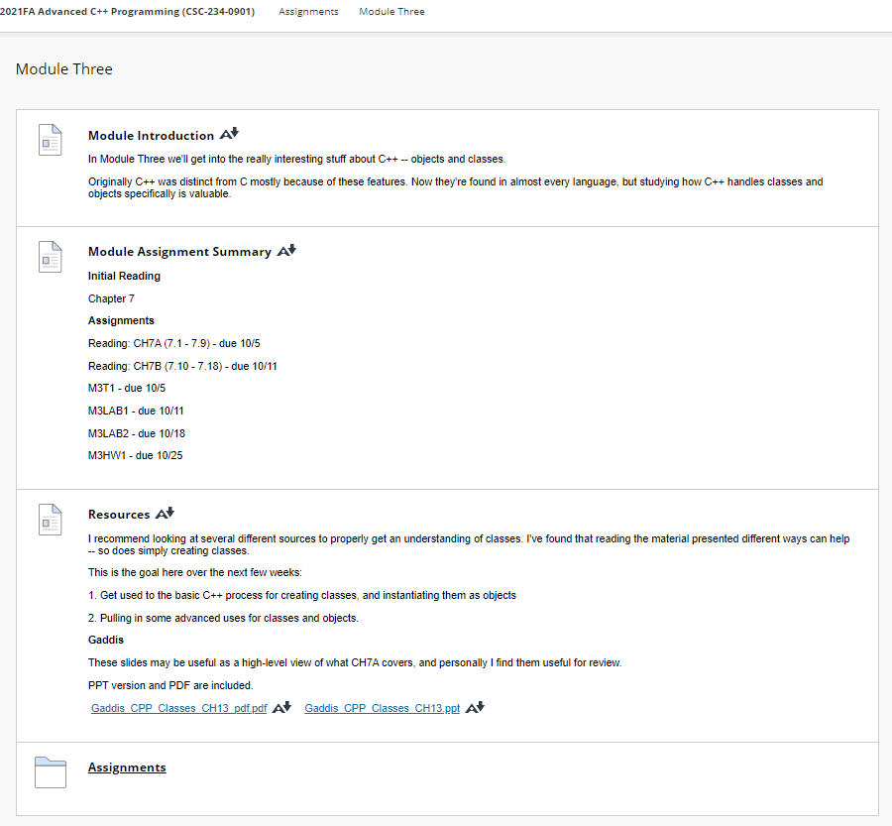

**Resources**

[Resources](https://faytechcc.blackboard.com/webapps/blackboard/content/listContent.jsp?course_id=_33824_1&content_id=_5842772_1)

I recommend looking at several different sources to properly get an understanding of classes. I've found that reading the material presented different ways can help -- so does simply creating classes.

This is the goal here over the next few weeks:

1. Get used to the basic C++ process for creating classes, and instantiating them as objects

2. Pulling in some advanced uses for classes and objects.

**Gaddis**

These slides may be useful as a high-level view of what CH7A covers, and personally I find them useful for review.

PPT version and PDF are included.

[Gaddis_CPP_Classes_CH13_pdf.pdf](https://faytechcc.blackboard.com/bbcswebdav/pid-5842775-dt-content-rid-54063192_1/xid-54063192_1) [Gaddis_CPP_Classes_CH13_pdf.pdf - Alternative Formats](https://faytechcc.blackboard.com/webapps/blackboard/content/listContent.jsp?course_id=_33824_1&content_id=_5842772_1)   [Gaddis_CPP_Classes_CH13.ppt](https://faytechcc.blackboard.com/bbcswebdav/pid-5842775-dt-content-rid-54063190_1/xid-54063190_1) [Gaddis_CPP_Classes_CH13.ppt - Alternative Formats](https://faytechcc.blackboard.com/webapps/blackboard/content/listContent.jsp?course_id=_33824_1&content_id=_5842772_1)